Overview of Fractions and some History

Percentages

Decimals

Multiplying and dividing fractions

Adding and Subtracting fractions

Fraction Equivalence

Ordering fractions

Partitioning   
the whole / unit into equal parts

Diagnostic Test

Overview of fractions

Fractions

**Some Historical Background to fractions**

The word fraction comes from the Latin word “**fractio”** meaning to break.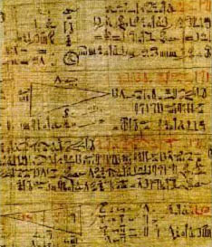 The beginnings of the fraction concept go back to very early times and it is nearly impossible to say when exactly they were first used. It is accepted that the concept of natural numbers comes from counting and the concept of fractions comes from measurement. The unit of counting is the indivisible “one” and the unit of measuring is the divisible measure – “unit”. Natural numbers will count any discrete quantity but to find ever increasing accuracy in the measurement of continuous quantities like length, time etc. led to fractions by dividing the unit into smaller parts. Fractions did not lead to absolute accuracy as ancient Greeks discovered line segments whose length cannot be expressed accurately by any fractions. To enable the length of any line segment to be expressed by numbers led to the introduction of the real number concept.

1800 BC

*Fractions in Babylonian cultures*

1650 BC

*Egyptians using unit fractions*

100 AD

*Chinese have a system for calculating with fractions*

1585

*Flemish mathematician Simon Stevin popularises decimal fractions*

1700

*The /used in fractions as in x/y is in general use.*

Around 1800 BC fractions were being used by Babylonian cultures.

Evidence of the early stages in the development of fractions can be found in Egyptian mathematics and the best source is the **Rhind papyrus** (dating from around 1650 B.C. but using ideas predating even this date). Fractions were very important to the Egyptians considering that out of 87 problems on the Rhind papyrus only 6 did not involve fractions.<http://www.daviddarling.info/encyclopedia/R/Rhind_papyrus.html>

Egyptian mathematics had no multiplication or division as we know it, only addition. Multiplication was done by successive doubling and adding.

The Egyptians only knew unit fractions and 2/3. All other fractions were expressed in terms of unit fractions. e.g.  One feature of the system is that there may be more than one way of writing a fraction. Five sevenths could also be written as .   
The same fraction could not be used twice so 2/7 could not be written as 1/7+1/7. 

A formula representing a sum of distinct unit fractions is known as an ***Egyptian fraction****.* Mathematicians still work on converting modern fraction notation to the Egyptian form.

If a unit was divided into five equal parts they wrote the sign for five with a special symbol over it and it read – fifth part. The remainder was four parts which could not be called four fifths since a four fifth part, stated as such, did not exist. They would also not read it as 4 x 1/5 as the concept of multiplication was not known in ancient Egypt.   
In the book of Genesis we find 4/5 treated the same way: “It will happen at the harvests, that you shall give a fifth to Pharaoh, and four parts will be your own.....”

**Fibonacci (c.1175-1250)** was the first European mathematician to use the fraction bar as it is used today.

**Prior knowledge of fractions for students entering secondary school  
See primary school books +teacher guidelines**

* A fraction as a part of a whole where the whole is partitioned into equal parts/fair shares.  
   A fraction helps us say “how much” when the quantity is not exactly measurable in whole numbers.
* Unit fractions – equal sized portions or fair shares (numerator =1 and denominator = a natural number)
* Equivalent fractions Primary school book definition; different fractions of equal value
* Common denominators (which are common subdivisions)
* Mixed numbers
* Improper fractions
* Adding and subtracting fractions
* Multiplying a fraction by a whole number, a whole number by a fraction and a fraction by a fraction
* Dividing a whole number by a fraction

However some **students still seem to have difficulties with the concepts when they enter secondary school**.

* If they are armed with only rules students have no way of checking if their results make sense. The many rules for fraction computation often become jumbled and students say things like “ do I get a common denominator or do I just add the top and bottom numbers like the rule I use in multiplication?” or “Which is it the first or the second number I invert when dividing?” In other words they are using rules with no reasons.
* Part of the difficulty is that in real life their experience of fractions is usually limited to halves, quarters and thirds.

**Where there are difficulties, students need to**

* **Identify what the unit/whole is.** The unit is different in different contexts. If we share 8 cookies among 4 people the unit is the 8 cookies. Each person gets 2 cookies i.e. of the cookies or of the cookies. Dividing one pizza among 4 friends, the pizza is the unit.
* Understand that the **parts which constitute the whole must be equal in area** if using an area model i.e. must understand the role which equality of parts plays in the generation of a fraction
* Develop **meaning for fractions** using a part whole model (e.g. fraction circles, fraction strips, the number line, uni-fix cubes). This will give students good mental representations of fractions.
* Develop **good ordering strategies** based on strong mental representations of fractions developed through the use of concrete materials without having to use common denominators.
* Have strong mental representations for **equivalence of fractions** based on concrete/pictorial representations.
* Spend time on concepts, ordering and equivalence ideas before working with operations. Both conceptual and procedural understandings are important for fraction operations.
* Use fractions to solve real world applications

***Initial fraction understanding should not include formal algorithms***. However if students already know the algorithms it is very important that they can make sense of them.

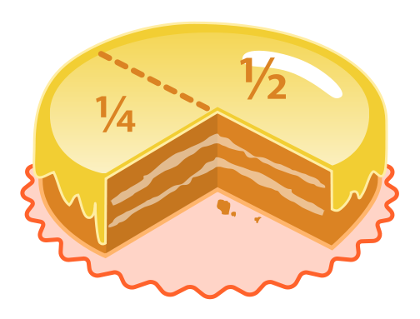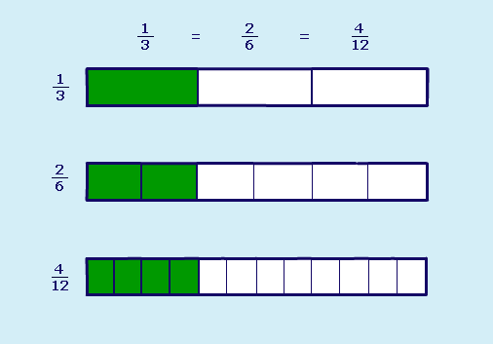**Research shows that trouble spots in algebra come from an incomplete understanding of initial fraction ideas.**

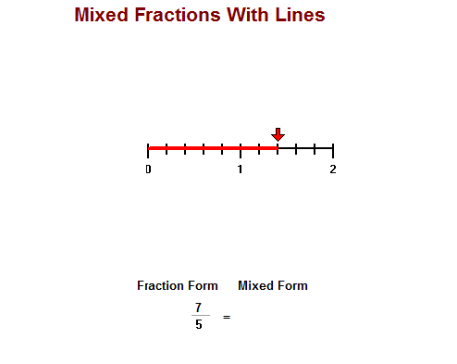

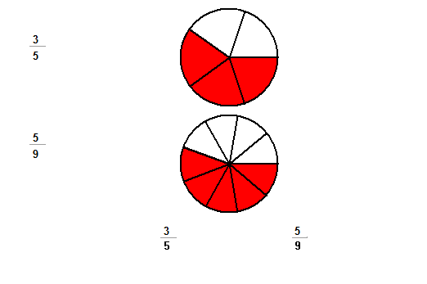**Resources and Methodology**

Manipulative models, pictures, real-life contexts, verbal symbols and written symbols – understanding is reflected in the ability to represent mathematical ideas in many ways

Students work as a class group discussing ideas with the teacher and in small groups where they discuss the mathematics involved and complete activity sheets.

They may use fraction strips, paper folding, fraction circles, counters, fraction towers, uni-fix cubes or the number line and draw pictures of the same to make sense of their work. Using problems set in a real world context, students move from the real world to drawing representations of the problem to using symbols.

Initial activities should involve the students’ definition of a fraction, their process of unitizing and partitioning, their sense making of the fraction symbols, and of order and equivalence of fractions.

Oral language

Pictures

Manipulative

Models

Written symbols

Real life contexts

Students need to be able to move between the different representations of a concept for a deep understanding of the concept**. It is very important that there is always a connection between the manipulative model and the symbolic form.**

Examples :

**Real life to manipulative to written**:

There were 30 students in the class. One third of them were girls and two fifths of the girls were on the girls’ basketball team. How many students in the class were on the girls’ basketball team?

(Students could use **counters** to model this and write a number sentence which could be used to solve it.)

**Real life to pictures to oral:**

Jill owned seven eights of an acre of land. She decided to plant potatoes on half of this land. What fraction of an acre did she plant with potatoes?

(Draw a picture to show the situation and explain how the picture can be used to find the answer.)

**Written symbol to picture to verbal:**

Use a picture to show 2/3 x ¾ and explain how to use it to find the product.

**Ordering Strategies which are not based on common denominator**

1. **Same denominator, different numerator** e.g. comparing and.   
   Students who have used unit circles or other manipulatives should reason that  >

 and  have the same size pieces (sevenths) and therefore 5 of them is greater than 3 of them – greater number of same size pieces.

1. **Same numerator, different denominator** e.g.  and   
   (same number of different size pieces)  
   Students should conclude that > since thirds are larger than fifths and two of the bigger pieces must be bigger than two of the smaller pieces. (The more parts the whole is divided into the smaller the parts.) Without a visual model students might use whole number strategies for ordering – 5 being bigger than 3.  
   (N.B. Just because denominators are smaller only means that the fraction is smaller when the numerators are the same. A student, *who only looked at the denominator*, without considering the numerator, might incorrectly say that  is smaller than  because quarters are smaller than thirds.)
2. **Comparing fractions to and 0 and 1**  
   For instance  is bigger than  and is smaller than  so therefore  >.

 is relatively small, close to 0 whereas  is between  and 1  
When comparing  and  students will know that =  whereas   
 = . As eights are bigger than ninths, therefore  is closer to 1 than and hence .

1. **Doubling each fraction**

e.g. comparing and . Both fractions are greater than ½. If we double both they increase proportionally and we are comparing 6/5 and 4/3.   
6/5 is only 1/5 greater than 1 whereas 4/3 is 1/3 greater than 1.   
Hence two thirds is greater than three fifths.

**N.B.** Students should know that fractions can only be compared when base unit or whole is the same.

One of the reasons why students may experience difficulties with fractions is the differing interpretations of fractions in different situations.

**Different meanings for fractions in different situations**

* 1. **Part – whole**: ¾ can represent 3 books out of a collection of 4 books or 3 equal slices out of a pizza cut into 4 equal pieces
  2. **Decimals** represent fractional parts of a unit where the partitions are powers of 10.
  3. **Ratio**: In this case the fraction represents a relationship between two quantities. It is a fraction when it represents the ratio between the part and the whole and not between the part and the part. For example, the ratio between the number of boys in the class and the total number in the class is a fraction but the ratio between the number of boys and the number of girls in the class is not a fraction.
  4. **Measure:** ¾ of the way from the beginning of a unit to the end of a unit
  5. **Operator** (fraction as a transformation) : find ¾ of 16
  6. **Quotient** (focuses on the operation): ¾ can be considered as the result of 3 divided by 4 or the result of sharing 3 bars of chocolate among 4 people.
  7. **Percentages** are fractional parts out of 100

**A suggested sequence of lessons on fractions leading onto decimals and percentages which are fractions with denominators of 10 and 100 respectively**

1. **Diagnostic Test**: Its purpose is to assess student’ level of understanding of fraction concepts. It is not a “test” as such but a way for the teacher to plan a program for a particular class, tailored to their particular needs. Students with high levels of proficiency will move very fast through the following activities but will benefit from a concrete reinforcement of concepts
2. Student activity in **partitioning** (involving equal parts, fraction equivalences, adding fractions, improper fractions, basic multiplication and division ideas – without algorithms)
3. Student Activity to develop **ordering strategies** not using common denominators
4. Activities for developing concept of **fraction equivalence** leading to an algorithm
5. **Estimating addition and subtraction** using concepts developed earlier on fraction size
6. **Addition and subtraction of fractions** and the need for common denominators
7. **Multiplication of fractions**
8. **Division of fractions**
9. **Decimal fraction concepts**
10. **Operations on decimals**
11. **Percentages**
12. Using the equivalence of fractions, decimals and percentages to reason proportionally

The amount of time spent on each “lesson” will depend on students’ understanding. It is vital that time is spent ensuring that the algorithms have meaning in terms of basic concepts.

|  |  |
| --- | --- |
| **Strand/Topic Title** | **Learning Outcomes**  *Students will be able to* |
| **Strand 3 :** 3.1 Number systems  Students will devise strategies for computation that can be applied to any number. Implicit in such computational methods are generalisations about numerical relationships with the operations being used. Students will articulate the generalisation that underlies their strategy, firstly in common language and then in symbolic language. | * generalise observations of arithmetic operations * investigate models to help think about the operations of addition, subtraction, multiplication and division of rational numbers * consolidate the idea that equality is a relationship in which two mathematical expressions have the same value * analyse solution strategies to problems * begin to look at the idea of mathematical proof * calculate percentages * use the equivalence of fractions, decimals and percentages to compare proportions |